Local commands:
1. Deleteing file: git rm filename.ext
2.Renaming file : git mv oldname.txt newname_txt
Tags:
-Tags are label to a commit
-Points to commit
Cmd: git tag v1.0
Cmd: git tag // list all tags
By default v1.0 -> latest commit id
Cloning:
cmd: git clone https://github.com/user/project.git
-from remote to local system
Renaming Branch:
-git branch -m newname.txt //renames current
-git branch -m oldname newname //renames different name
Rebase:
main has A and B ..and Features has A and B also....when E F created in Main and F has C and D ... if i do rebase in feature branch git rebase main.,. In featues,, C and D removed and gets latest branch of main and adds C and D at last for features branch...
-cmd: git rebase main
Restore:
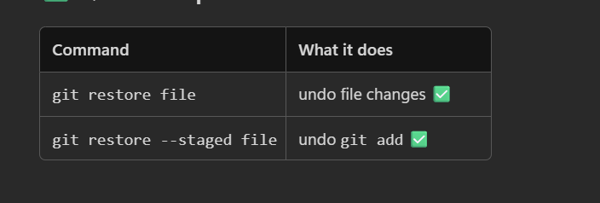
Reflog:
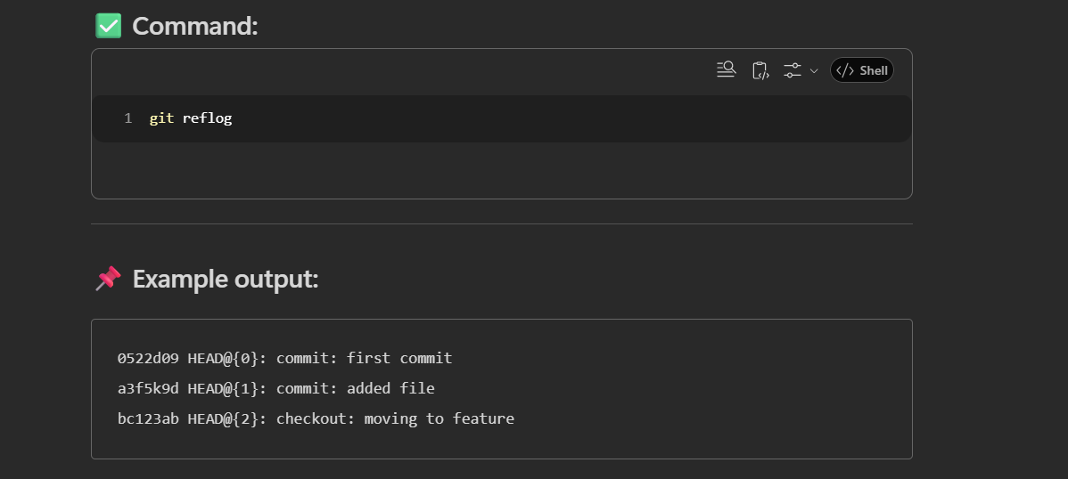
-all the activates u did and explains where and what was the HEAD

